Polynomial Regression
In the previous article, we read about how can we make a Machine Learning Model for linearly depending output. However, the input output relation may not always be linear. Polynomial Regression is a type of regression which can create non-linear models.
Mathematically,
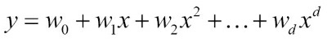

It is same like Multiple Linear Regression but the variable X is in different powers(1,2….d).
We use Polynomial Regression when straight line can not fit the data.
Let’s say we want to fit the model using Simple Linear Regression.
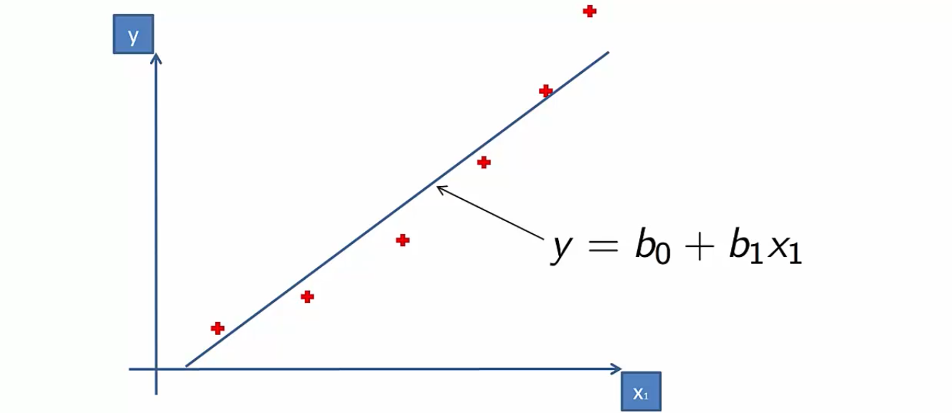
This may not be the best fit. But, if we used Polynomial Regression for the same data. It gives amazing results.
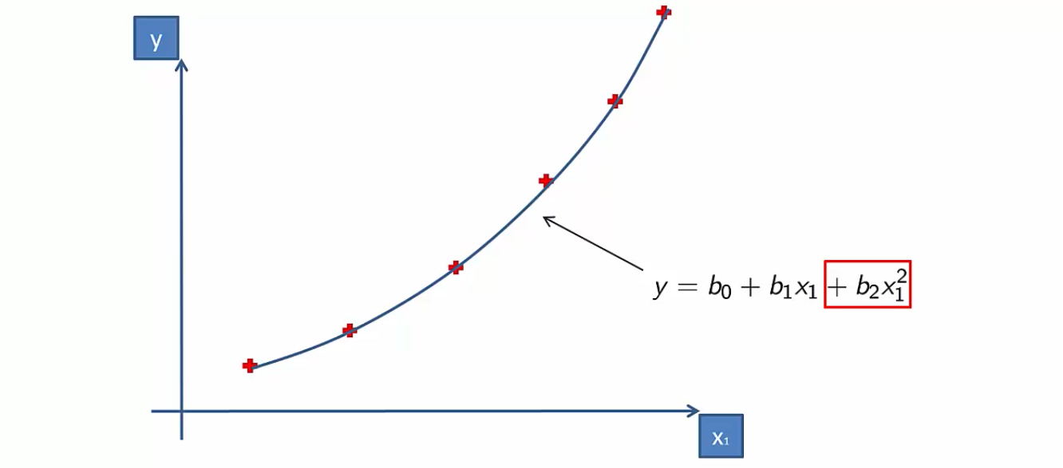
Now, let’s begin the code. Building our Polynomial Regression Model.

Getting the Data
You can download the data for this section from here. If you download and see the data-set, you will see, you have Position, Level and Salary of the employee. Let’s plot Level vs Salary graph and see how the data is distributed.
Initially, let’s import the required libraries:
import numpy as np
import matplotlib.pyplot as plt
import pandas as pd
Now, its time to import the dataset and divide data into input and target. Here, we take level as input and want to predict salary. So, we will put Input as X and Salary as y.
dataset = pd.read_csv('Position_Salaries.csv')
X = dataset.iloc[:, 1].values
y = dataset.iloc[:, -1].values
Now, let’s plot X vs Y. You can see how is the data distributed. If you try fitting the model using Linear Model, you cannot get the best model.
plt.scatter(X, y, color = 'red')

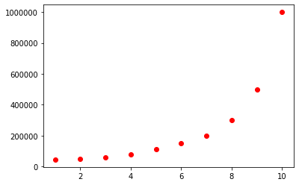

You can split the data into train and test set and find the model accuracy. We have done this in previous section. We are not doing in this one.
We are directly creating a Polynomial Regression. There is no Polynomial Model. We only take Polynomial Features of required degree and fit it into Linear Regression Model.
from sklearn.preprocessing import PolynomialFeatures
from sklearn.linear_model import LinearRegression
poly_reg = PolynomialFeatures(degree = 4)
X_poly = poly_reg.fit_transform(X)
lin_reg = LinearRegression()
lin_reg.fit(X_poly, y)

Now, let’s plot and see how our model preformed in the data.
plt.scatter(X, y, color = 'red')
plt.plot(X, lin_reg.predict(X_poly), color = 'blue')
plt.title('Polynomial Regression')
plt.xlabel('Position level')
plt.ylabel('Salary')
plt.show()

After plotting you can visualize:
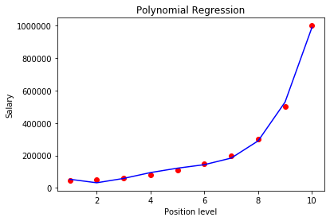

WORK:
For the same data create a Linear Regression Model and Compare the output. Which model will perform better either Linear or Polynomial Regression.
Comment Down Your Work!! Cheers and Keep Learning.

Hope you have tried this, If not, then:
Initially create Simple Linear Regression Model on same X and y.
from sklearn.linear_model import LinearRegression
lin_reg2 = LinearRegression()
lin_reg2.fit(X, y)

We have Linear Regression Model ( lin_reg2) and Polynomial Regression Model (lin_reg). Now, let’s predict the salary of employee with level 7 which is equal to 2 lakh.
Using Linear Model,
lin_reg2.predict([[7]]) == 370000
Using Polynomial Result.
PTR: We need to covert the input to Polynomial Features. So,
lin_reg.predict(poly_reg.fit_transform([[7]])) == 184000
You can see which model has best fit.

